CONTROL SYSTEM QUIZ#1 – ERASMUS 2018-2019

NAME

The temperature control system in the human body is an example of a closed-loop control system.
True
False

The diagram below shows a closed-loop control system. What element is represented by the circle labeled X?

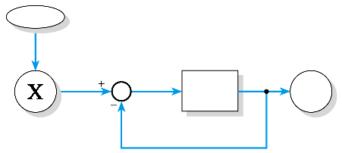
The user.
The goal.
The forward path.
The error signal.

In a temperature control system, what represents the output of the system?
The actual temperature achieved.
The heat produced by the system.
The heating element.
The required temperature.

What is the voltage gain of the following arrangement?

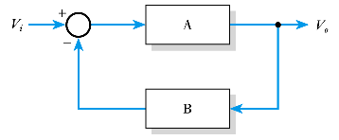
A/(1+AB)
B/(1+AB)
(1+AB)/B
(1+AB)/A

Under what conditions does the gain of a feedback system approximate to 1/B?
The feedback path gain B >> 1.
The loop gain AB >> 1.
The loop gain AB << 1.
The forward path gain A >> 1.

What is the gain of the following passive attenuator?

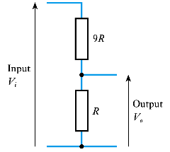
0.1
0.11
9
10

What is the effect of negative feedback on the gain of an amplifier?
It reduces the gain by a factor of 1/B.
It increases the gain by a factor of (1 + AB).
It increases the gain by a factor of 1/B.
It reduces the gain by a factor of (1 + AB).

What is the effect of negative feedback on the bandwidth of an amplifier?
It increases the bandwidth, often by a factor of (1 + AB).
It reduces the bandwidth, often by a factor of 1/B.
It reduces the bandwidth, often by a factor of (1 + AB).
It increases the bandwidth, often by a factor of 1/B.

What are the effects of negative feedback on the input and output resistance of an amplifier?
It decreases input resistance and increases output resistance.
It increases both input and output resistance.
It can either increase or decrease the input and output resistance depending on how it is applied.
It increases input resistance and decreases output resistance.

Negative feedback reduces the noise corrupting a signal by a factor of (1 + AB).
True
False

